**Feedback:** You will be able to answer the core about agile practice adoption as part of your results when answering the first question. If you do want to ask the second question (i.e. “…how can…”), then specify these as two separate questions you can answer later.

**Heading: Main Research Question**

**Answer:** Thank you for the suggestion. I agree with your point and will go with the first question only, focusing on how Agile adoption differs between safety-critical and non-safety-critical environments.

**Feedback 2:** You need to change how the literature relates to your project.

Heading: 1.5 Application of Literature to Your Project: **Answer:** Apologies, that was an oversight. I’ll correct it to properly show how the literature connects with the proposed project.

**Feedback 3:** I know you have done this, as the data has many missing values, but do include fragments in the appx to indicate this work in the final report.  
**Heading:** 2.4 Dataset Preparation (HELENA Dataset Work):  
**Answer:** Thank you for the suggestion. I will include screenshots of the data preprocessing steps in the appendix of my final report. I’ll also upload the related code and dataset preparation work to GitHub for transparency and future reference.

**Feedback 4:** Why are you doing this? Just remove missing values. This sounds odd, and you will need to show how you achieved this! **Heading: : 2.4 Dataset Preparation (HELENA Dataset Work):**

**Answer:** My intention was to refer to the values/columns that were already present in the Excel sheet, which I related using the PDF. However, I understand your point and I will improve the explanation and make it clearer in the final report.

**Feedback 5:** So, why not initially run some descriptive statistics, to look for patterns in the data. Then run some visualisations, e.g. a normalised stacked bar plot. (Your RQ2 I thought was going to ask about the differences in proportions of agile practice vs Safety/non safety critical development?) Finally you run your chi-square test to see if what you observe as potential differences are significant. Now… you have been very clever in identifying that safety… **Heading: 2.5 Preliminary Data Analysis**

**Answer:** detailed answer is quoted below.

“To find out if Agile usage differs between safety-critical and non-critical companies, I used a chi-square test. This test compares what I actually observed in the data with what I would expect if there was no relationship between Agile usage and software type. I created a contingency table showing that 30 critical companies used Agile, compared to 205 non-critical ones. The expected value for Agile use in critical companies, calculated using the formula

(Row Total × Column Total) ÷ Grand Total,

was 38.21 — but I observed only 30. This small difference gave a p-value of 0.1157, which is greater than the 0.05 threshold. So, the result is not statistically significant, meaning the difference could be due to chance. Even though the chart shows that 25.4% of critical companies use Agile compared to 7.2% of non-critical ones, the test shows that this difference is not strong enough to confirm a real relationship in the population. Therefore, I failed to reject the null hypothesis, concluding that Agile usage does not significantly depend on whether the company is safety-critical or not.”

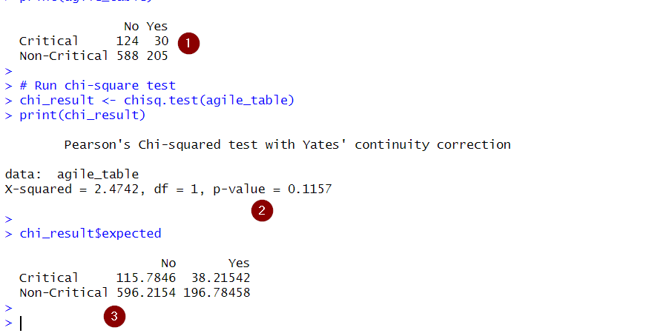

**Feedback 6:** Your data is nominal (i.e., categories like ‘Agile’ or ‘Critical’ — not numbers). So you don’t need regression. Regression is only used when your data is numeric. What variables are you even using? You don’t need to do this — just stick to basic statistics that make sense for your type of data.

**Heading:** **2.7 Challenges Faced and How They Were Addressed**

**Answer:** I will use descriptive statistics, visualizations (e.g., bar charts, pie charts), and chi-square tests to explore and compare Agile adoption across critical and non-critical software environments

**Feedback 7:** All three of these bullet points are just copied, say why you include them and if they do or do not relate to your research.  
**Heading: Ethics Approval and University Procedures  
Answer:**  Yes, the bullet points were initially referenced and adapted from standard university guidance to ensure alignment with ethical requirements. However, I understand the importance of clearly linking them to my own research. I will revise and explain each point to show whether it is relevant or not to my project, and adjust the wording as needed to better reflect my specific study.

**Feedback 8:** Provide the ResearchGate link or required citation for this. Not just the name. So the first time you mention it, cite the source precisely.

**Heading: 3.9.1 Intellectual Property & Citation Integrity**

**Answer: researchgate helena link**

**Feedback 9:**Do not state that you yourself are using agile methods to run the stats and write up the report. The methods are designed for teams of developers. How are you using the methodology? Also, are you really using GitHub and Jira? Show me please in screenshots. And explain how this is necessary for a one person report (You can of course use these methods as a lone researcher, but why?).

**Feedback 10:** Show me the tracking of Jira.

**Heading: 4.1 Project Management Approach**

**Answer:** I am using GitHub to store my project files and version history, as recommended by the module leader. Initially, I planned to use Jira for task tracking and created an account, but after receiving feedback and realizing this is an individual project, I decided it wasn't necessary and chose not to continue using it.

**Feedback 11:** Who from your peers are reviewing this?

**Heading: 4.5 Evaluation and Quality Assessment**

**Answer:** I initially included the term “peer review” because I misunderstood its meaning. I thought it referred to the ongoing feedback I receive from my supervisor during the research process. However, after researching the term further, I now understand that peer review refers to feedback from classmates, colleagues, or other researchers at a similar level — not supervisors. Since I have not received formal peer feedback, I will remove this from my documentation and keep only the mention of supervisor guidance.

**Feedback 12:** Why does your key say “Non-Critical”  
**Heading: Figure 4: Screenshot showing agile Adoption in Safety-Critical Software.**

**Answer:** The label ‘Non-Critical’ is used to represent organizations that do not identify their software as safety-critical.  
  
**Github repo link**: <https://github.com/rk23adt/FPR>

**Picture:  
 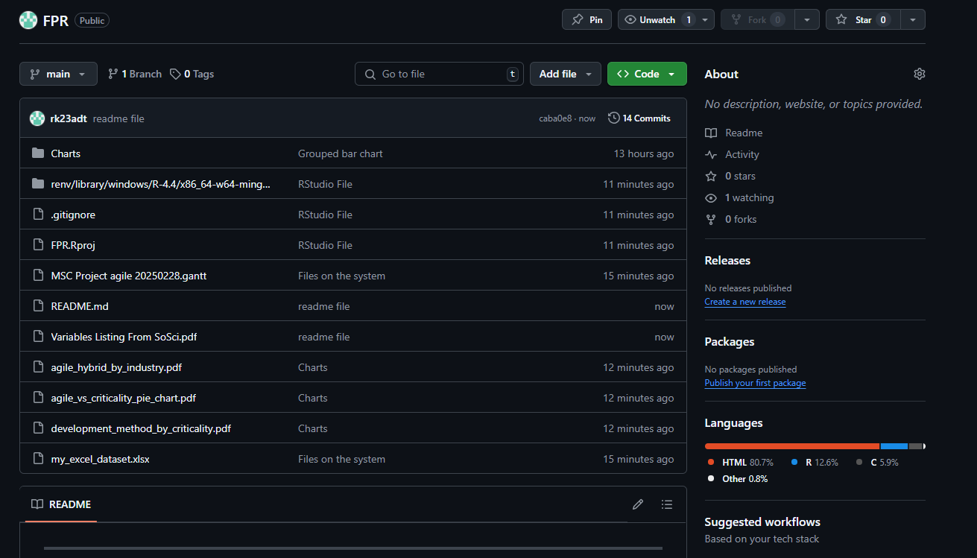**

**RQ:** How does the adoption of Agile methodologies differ between organizations developing safety-critical software systems and those developing non-critical software systems?

* **Safety-Critical Software vs Non-Critical Software**
  + **Safety-Critical Software (Critical Systems)**
    - Automotive Software and Systems
    - Aviation
    - Defense Systems
    - Medical Devices and Health Care
    - Space Systems
    - Robotics (autonomous robots, UAVs/drones)
    - Energy (e.g., Smart Grid, nuclear, renewable energy)
    - ***If the company's software failure can:***
      * Threaten human health or life
      * Lead to complete system loss
      * Have legal consequences (civil or criminal law)
      * Impact the environment significantly
  + **Non-Critical Software (Non-Critical Systems)**
    - Cloud Applications and Services (e.g., SaaS, data storage)
    - Games
    - Home Automation and Smart Buildings
    - Media and Entertainment (e.g., streaming, social media)
    - Mobile Applications
    - Web Applications and Services (e.g., portals, e-commerce)
    - Other Information Systems (e.g., ERP, SAP)
    - If the software failure mainly leads to:
      * System/service degradation
      * Financial loss
      * Reputation damage

**Question: How I Extracted Insights from the Dataset and PDF**

**Answer:** To answer the research question, I started by carefully examining the provided Excel dataset along with the PDF file that described the variable codes. From the PDF, I identified that the fields under D006 relate to the criticality of the software system. These fields include options like "threat to human life", "legal consequences", and "environmental damage". According to the PDF, if any of these options are checked (value = 2), the project is considered safety-critical. Using this logic, I created a new column in the dataset to classify each company as developing either Critical or Non-Critical software.  
  
Next, I focused on understanding the development methodologies used by these companies. The PDF showed that the PU09 fields indicate the methods being used, such as Scrum, XP, Kanban, and SAFe, which are known Agile practices. If any of these Agile methods were checked, I classified the company as Agile. If they used traditional methods like Waterfall or V-Model, I marked them as Non-Agile. Companies that used a mix or had unclear responses were labeled as Hybrid.

After creating these classifications, I combined the two new columns to form a category like “Agile – Critical Projects” or “Non-Agile – Non-Critical Projects.” I then calculated the percentage of each group and visualized the results in a pie chart. This allowed me to clearly see how Agile methodologies are adopted differently in safety-critical versus non-critical environments.

**Exercise: How I Implement in RStudio**

1. Load necessary libraries to read Excel and plot charts  
   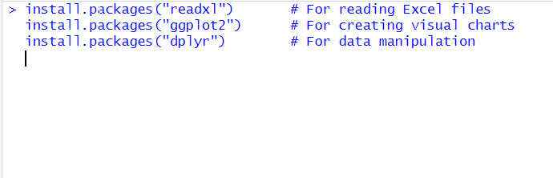  
     
   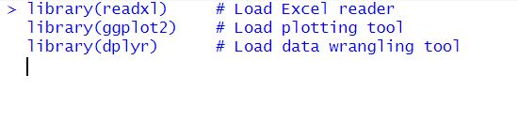
2. Install library to import excel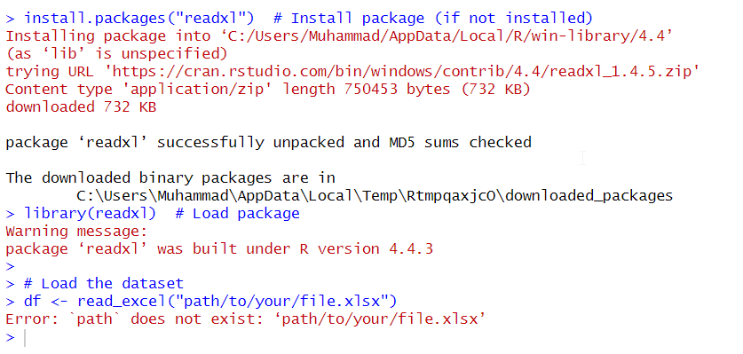
3. Import excel from
   1. File
   2. Import dataset
   3. Browse
4. Imported Excel file successfully and store into a user-friendly dataset name
   1. my_excel_dataset <- X2018_11_27_Full_Anonymized
5. Classify companies as critical or non-critical.Used the values from field D006_* where checked options =2, mean the software has serious consequences if it fails, such as:
   1. Threat to life
   2. Financial loss
   3. Legal issues

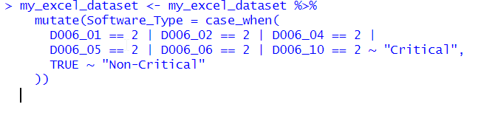

1. This combines Software_Type and Development_Method to group companies int
   1. Agile with Critical Projects
   2. Agile with Non-Critical Projects
   3. Non-Agile with Critical Projects
   4. Non-Agile with Non-Critical Projects  
      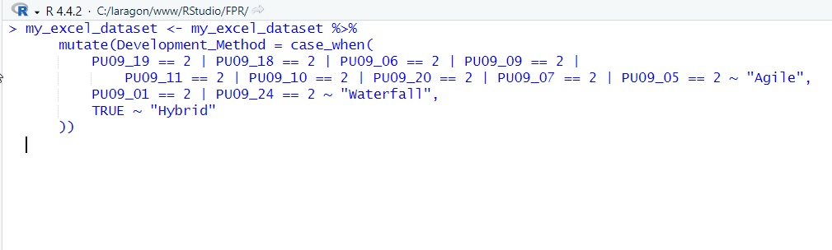
2. Group and calculate percentage for pie chart. Grouped by the new Category column and calculated the percentage of each group for the chart labels.  
   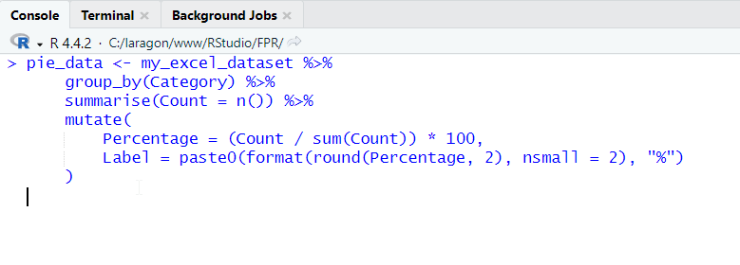
3. I manually picked readable colors to make the chart more professional and easier to interpret.  
     
   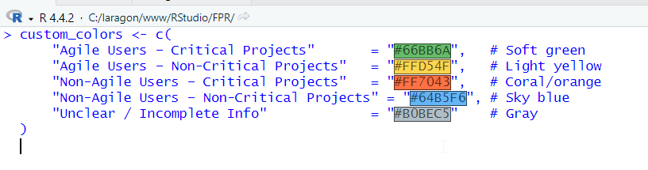
4. Create the final pie chart with title and percentages  
     
   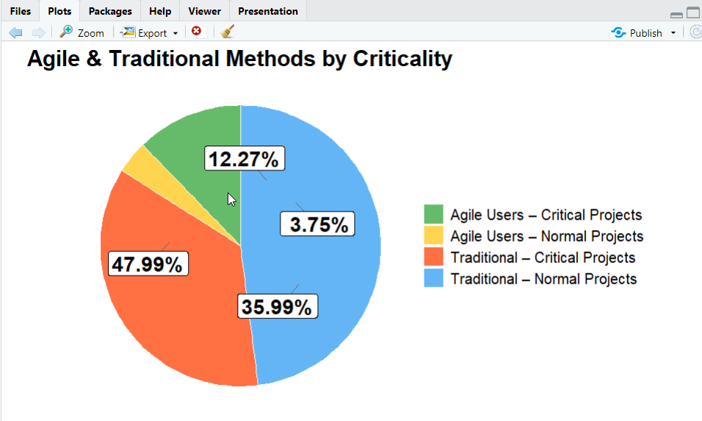
5. Save the chart as high-resolution PNG for reporting  
   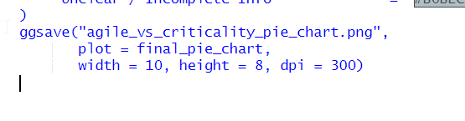
6. Bar Chart  
     
   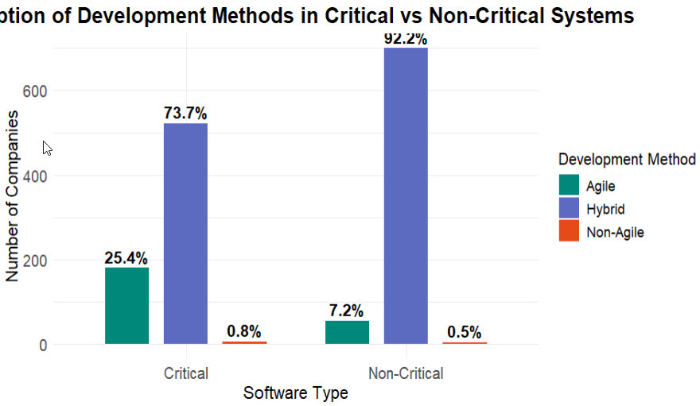
7. Grouped Plot Charts on behalf of checked =2  
   